Binary classification:

This means classify with yes or no (1 or 0). In computer pictures are in rgb matrices eg if size of image is 64 X 64 then it would contain 3 matrices of 64 X 64. To turn this pixel intensity values in feature vector we need to unrow all of these pixel values into input feature ‘X’, to unrow we will define feature vector X as column matrix (vector) with all three matrix (rgb) vector size is 3*m*n (3*64*64 = 12288) this is represented by n=nx=3*m*n called as size of input feature this would be used to classify.

Size if feature vector is nx ,m where nx🡪number of input features (number_of_channels * width * height) and m in number of examples

Y🡪 output vector shape🡪(1,m)

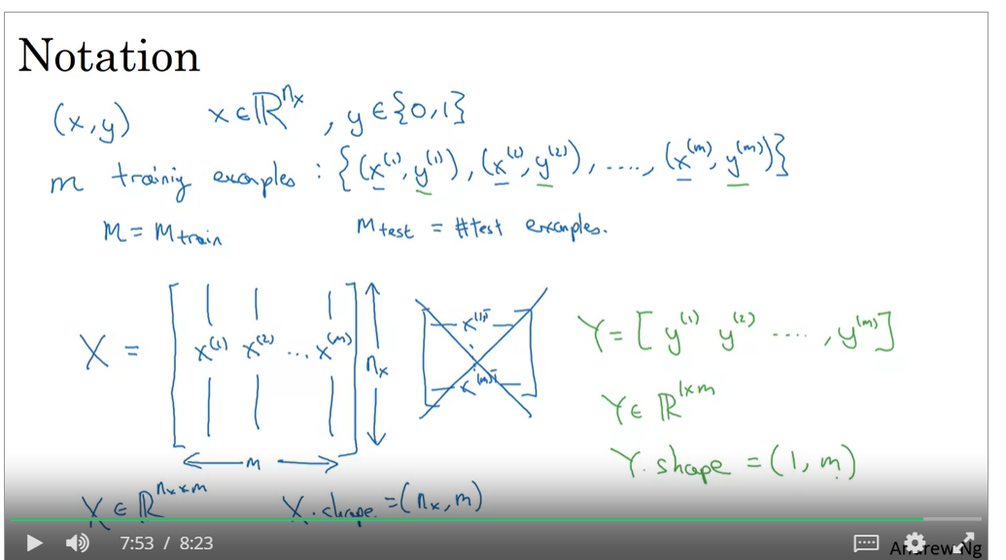

Logistic Regression:

sigmoid function

